**HTML Tutorial**

**\*HTML Verison 5\***

**=> Deprecated tags**

**Tags was available at HTML4 and won’t be more available at HTML5**

1. **<acronym> : for give explain when you come with mouse in the word , it’s replaced to be <abbr>**

**<abbr title=”explain”>word</abbr>**

1. **<appleat> replaced to be <object>**
2. **<basefont> & <big> & <font> & <strike> & <tt> => can do it with CSS**
3. **For all tags available or not you can visit : mdn html elements**

**=> Semantics**

**Tag = the meaning for what it do**

**Semantics tag = <form> <img> // not Semantics tag = <div> <span>**

**New semantics at HTML 5**

**Html 4 = <div class=”header”><div> // Html 5 = <header></header>**

**New sematics : <header><footer><section><nav><article>**

**==========================================================**

**=> New tag <progress></progress>**

**That make loading bar for any thing long**

**Code : <progress value=”7” max=”10”>design</progress>**

**==========================================================**

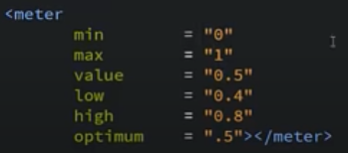**=> New tag <meter></meter>**

**==========================================================**

**=> New tag <details></details>**

**For make something hide when you click on it it’s show for you**

**You can use <summary>for give the details address will show for user</summary>**

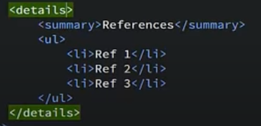**You can make it’s open default by use <details open>**

**==========================================================**

**=> New tag <mark></mark>**

**For make a mark for any words with color, also you can edit it with css**

**==========================================================**

**=> New tag <figure></figure>**

**That place to describe some thing or you can photo or p , Some thing like div**

**You can use <figcaption></figcaption>**

**It’s like legend in field set , give address to figure**

**==========================================================**

**=> New tag <time></time>**

**It’s have lot of features**

1. **If you use it can any one form other location transfer it to his local time**
2. **Help in search engine**

**Syntax for time tag :**



**==========================================================**

**=> New tag <bdi></bdi>**

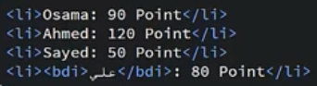

**To enter the Arabic in English and to don’t make bad shape for page**

**==========================================================**

**=> New features <datalist></datalist>**

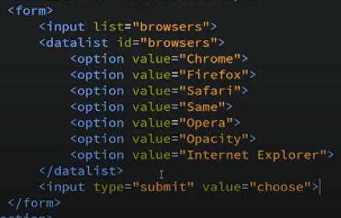**It’s place to write and choose**

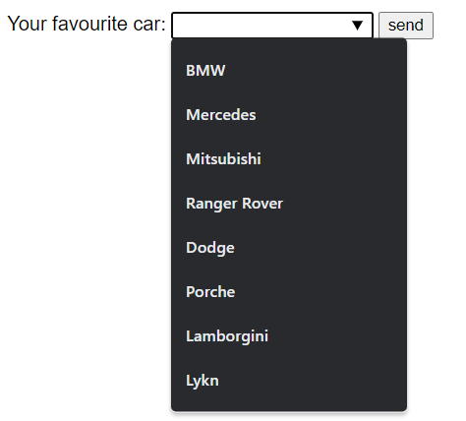**Page :**

**==========================================================**

**=> Audio with HTML 5**

To add audio file like music

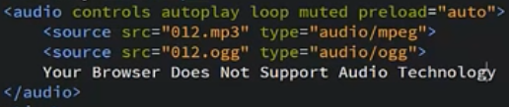Code syntax :

1. controls : to show control tools like play/pause and volume level
2. autoplay: to play it automatic when you open the page (no need to press play buttom)
3. loop: to make it after finish work again
4. muted: to start video but with no sound
5. preload: to make it load auto when open page (no need to press play to load it ) ,can make it (auto or none for don’t load or metadata for load data of audio
6. <source >: to give it sorce of audio (address of it )

After close the tag you can leave msg if the browser don’t support that audio type

**==========================================================**

**=> Video with HTML 5**

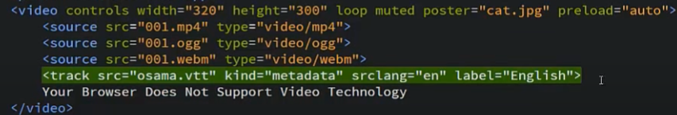**Code syntax:**

**There some attribute like audio**

**New attribute is poster > it’s to add photo like a poster for video before it play**

**Other thing is <track> it’s for translate video but it’s not like to be used, you can translate video with programs for montage etc.**

**=> New input on HTML 5**

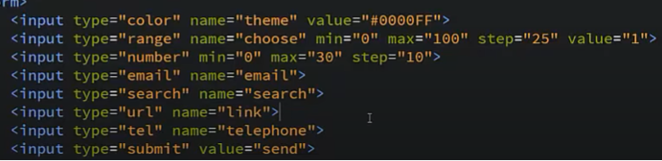**1) 1) input color: to choose color and send it to data base**

**2) input range: to make a bar with range and you select it**

**3) input number: to enter number and send it to data base**

**4) input email: that input accept only emails with @**

**5) input search: search bar in ur website**

**6) input url: to add url for ur website**

**7) input tel: it’s unsupported for browsers only work on apple safari**

**==========================================================**

**=> New input attributes on HTML 5**

**1) autocomplete: when you double click in input box you can see history of inputs you can make it by add**

**<input autocomplete=”on”> OR <input autocomplete=”off”>**

**2) autofocus: when you open the page make it write some where default**

**3) novalidate : to stop validation form input text**

**4) placeholder : I know it well**

**5) multiple : to make the input text take more than 1 input**

**6) Required : must write that text or won’t send**

**==========================================================**

**=> New form features**

**You make form to send data in one package but if you have form at the header and input at the footer, that one in the footer won’t count in data base so you can make it one by add**

**The form in header :<form ID=”main-form”></form>**

**And add his id on input : <input form=”main-form>**

**==========================================================**

**stop at canvas because it’s need javascript**

**We will back again after finish css3 and finish JavaScript also**

**Good Luck dude <3**